**Overview of Macros**

The two macros, referred to as Macro 1 and Macro 1b, work in tandem to process images in a stepwise manner. Macro 1 focuses on creating masks based on gray values from the input images, while Macro 1b operates blurring on these masks. These macros can be combined into a single workflow as they work sequentially.

**Macro1 binary spilt flowchart**

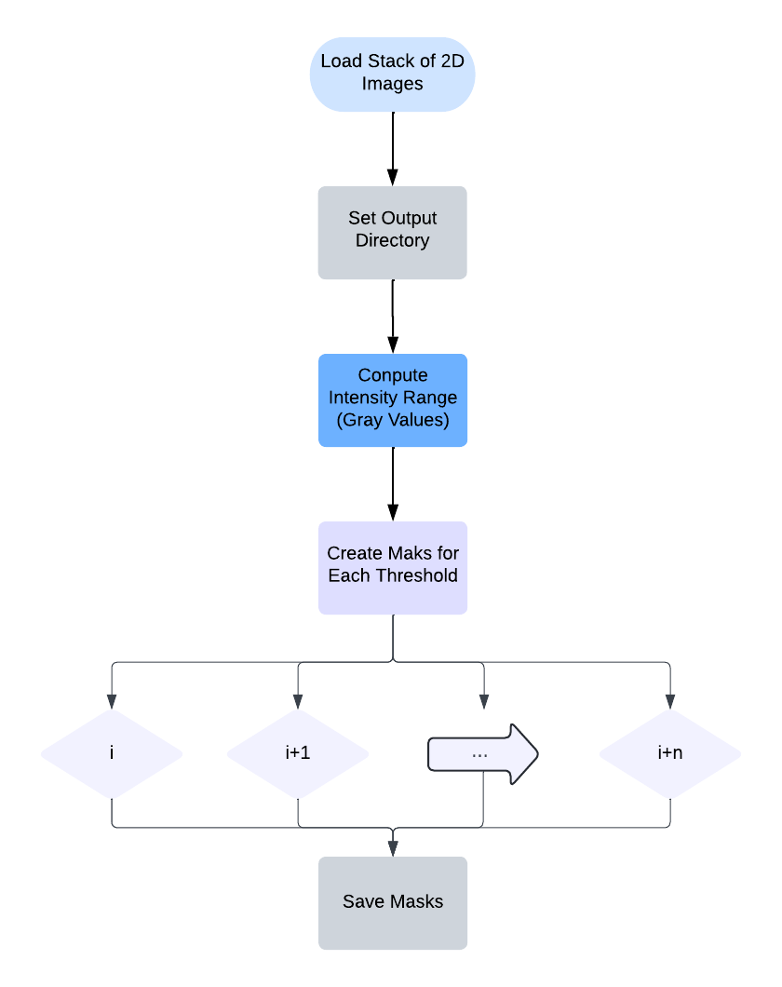

**Insight:**

* **Max Projection Step:** In ImageJ, the Z-Projection step is used to convert a 3D image stack into a 2D image. This step is needed because ImageJ is an image-based platform which lacks the ability to process 3D arrays in the same way scientific array-based software like Python does. Therefore, using Max Projection allows ImageJ to "squish" the 3D stack into a 2D image and extract unique values across the stack.
* **Image Statistics:** After the max projection, ImageJ uses the image statistics function to determine the maximum gray value across the stack, which is used for generating masks.
* **Workaround in Python:** Unlike in ImageJ, the Python workflow allows for directly pulling out the unique values in the 3D array without requiring the Max-Projection workaround. In ImageJ, projecting the stack into 2D for maximum gray value analysis is required due to this limitation.

**Macro1b 3d blur flowchart**

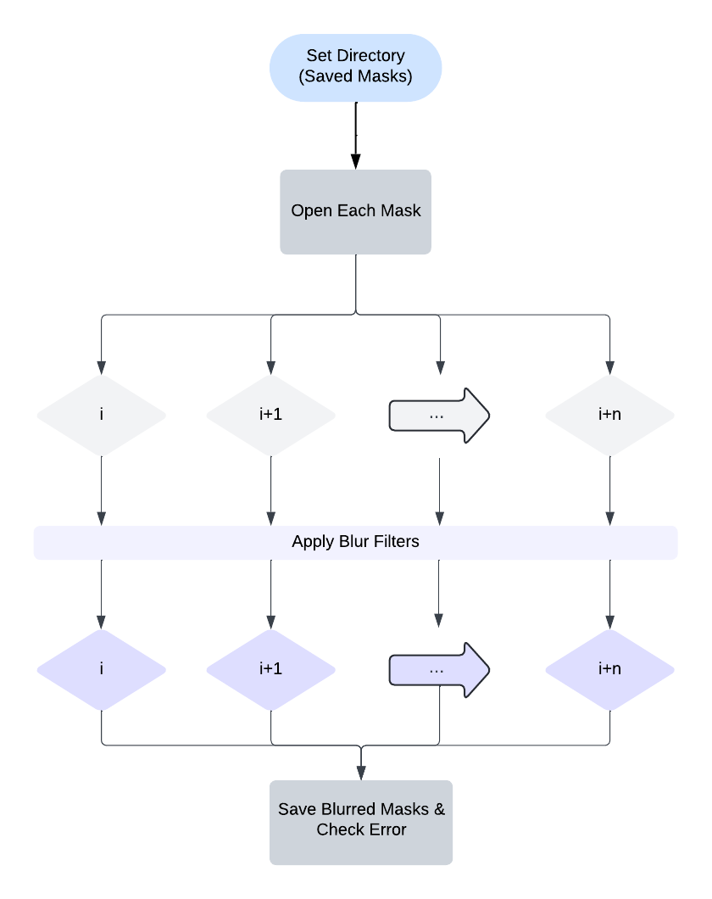

**Insight:**

* **Combining Macros:** Macro 1b could sequentially start from the end of Macro 1 to eliminate the need to reopen files and streamline the workflow.
* **Blurring:** This macro is primarily working on blur operation to the masks generated in Macro 1, which helps smooth out the image data.

**What is Batch Mode?**

**Batch Mode** in ImageJ allows for automating a macro across multiple files in a folder. Thus, ImageJ is able to apply the same macro operation to each file sequentially without requiring user intervention for each step.

In our current macros, batch mode is set to true, but due to the way our macros are structured, this is redundant. The macro already contains a loop to process multiple files, making the batch mode setting unnecessary. Disabling batch mode would have no effect on the output or functionality.